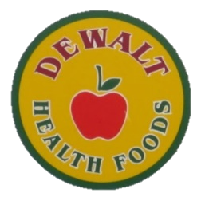
DeWalt Health Foods
Fall Open House
November 11th, 11-3PM
Join Us to Meet the Representatives from Your Favorite Companies & Enjoy Some Deliciously Healthy Food with a Thanksgiving Theme

- Arthur Andrews
- Barleans
- Bluebonnet
- Bionox
- BioSil
- Bucklebury
- Butler Coffee Lab
- Charlotte’s Web
- CofixRX Nasal Spray
- DeWalt’s Aromatherapy & Herbs
- Dr. Ginger’s
- Dr. Mercola Products
- Earth’s Care
- Earth’s Cures
- Enzymedica
- Essiac – From Rene Caisse
- Fruily Gummy Vitamins
- Gabriel’s / ZuZu Natural Cosmetic
- Garden of Life
- Good Light Candles
- Grounds & Hounds Coffee
- Health Direct
- Herbs Etc.
- Heritage Store
- Himalaya
- Host Defense
- Hyalogic
- Ion Biome
- Jarrow
- Kal
- Life Extension
- Mara Labs
- Maroma Incense & Perfumes
- Maximum Living – MineralRich
- Med Free Living
- MG12 - The Power of Magnesium
- Nantucket Spider
- Natural Factors
- Natural Path Silver Wings
- Nordic Naturals
- North American Herb & Spice
- Nutrex
- Nutritional Frontiers
- Plus CBD Oil
- Redd Remedies
- Silver Biotics
- Skin Drink
- Solaray
- Solgar
- Sunwarrior
- Terry Naturally
- Tulip Perfumes
- Vital Planet
- Wiley’s Fish Oil
- Zand
- ZHOU
- Zum By Indigo Wild
And Many More…
***FREE PARKING IN THE DIAMOND LOT BEHIND THE STORE
*FREE Gifts with Purchase – Up to $375 FREE Items
*FREE Goodie Bag with purchase to First 200 customers

